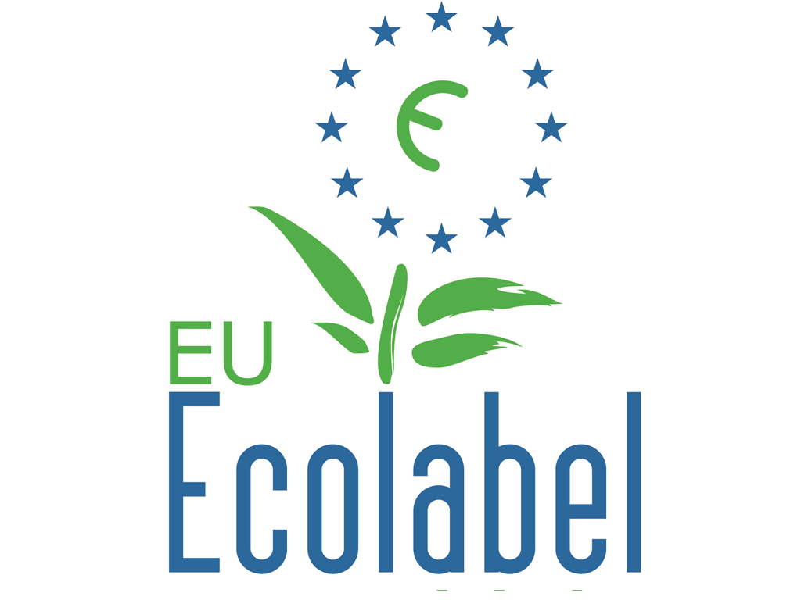
Ecolabels provide a reliable guideline for purchasing environmentally friendly products.
<March>
<Year>
<Company
logo>
Go for green products!
<company> accepts the corporate responsibility and is implementing appropriate measures.
A certified environmental management system is a support mechanism to manage and reduce environmental impacts caused by products, services and other company activities, thereby improving environmental performance of the business. This is supported by the purchase of products with eco-friendly labels and from companies which also apply environmental management systems.

- The EU-Ecolabel is ratified in 28 European member states, as well as Norway, Iceland and Liechtenstein. Since 1992 when it was first introduced with the EU directive EWG 880/92, the label has evolved into a reference for eco-friendly products and services. It covers over 700 products in 35 categories, including any products used in offices, such as electronic equipment, paper, cleaning products and furniture.
- The FSC and PEFC labels denote sustainably sourced paper which is not recycled.
- The EU organic logo identifies organic food which has a much lower impact on the environment.
TIP: Any of those labels can be purchased for households, too!
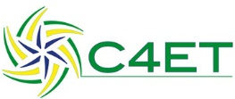
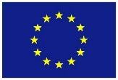
Co-funded by the Erasmus+ Programme of the European Union
„The European Commission support for the production of this publication does not constitute an endorsement of the contents which reflects the views only of the authors and the Commission cannot be held responsible for any use which may be made of the information contained therein.”
Contact: <Name>, <mailcontact@companyname.eu>
Kontakt: Marina Musterfrau, musterfrau@beispielfirma.de

