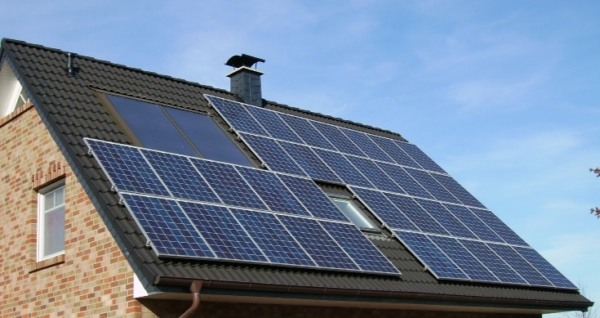
Energy management for the efficient use of energy supports corporate strategies, saves production costs and promotes the implementation of CSR-goals. The use of renewable and other sustainable sources of energy is one pillar in that respect. Private households have similar options to companies:
<Company logo>
Photovoltaic systems and solar collectors generate electricity and heat
<June>
<Year>
<Company logo>
Power for the future

- Photovoltaic: Photovoltaic cells convert sunlight into electricity. This can be used immediately, stored in batteries or fed into the public grid.
- Solar thermal energy: Sun collectors generate heat which can be used as process energy, for warm water supply and for the heating system.
- Cogeneration of electricity and heat: Cogeneration systems capture the lost heat of electric generation and redirect it for production and other purposes.
- Purchase of renewable energy from energy provider: If the production of energy by households or companies is not suitable, they can order electricity from renewable sources and biogas for heating and other purposes.
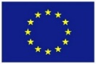
TIP: Check EU and country grant programmes to generate your own
power and heat at home!
Co-funded by the Erasmus+ Programme of the European Union
„The European Commission support for the production of this publication does not constitute an endorsement of the contents which reflects the views only of the authors and the Commission cannot be held responsible for any use which may be made of the information contained therein.”
Contact: <Name>, <mailcontact@companyname.eu>
Kontakt: Marina Musterfrau, musterfrau@beispielfirma.de

