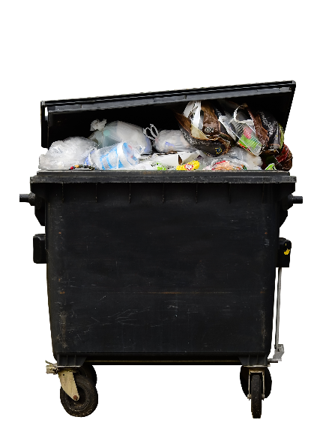
No company accepts avoidable waste! Efficient use of introduced raw materials for production and processes is essential to face current global challenges. Waste management is costly, thus in the business-to-business sector, refill containments and deposit systems are commonly used.
<Company logo>
<September>
<Year>
<Company logo>
Avoid waste!
Every EU citizen produces an average of 476 kg waste per year. All the plastics, glass, paper etc. need to be produced which entails a tremendous CO₂ footprint that can easily be reduced. Some simple measures to reduce
waste and its severe environmental impacts:
- Rechargeable batteries can be reused many times.
- Plastic bags can be used several times for various purposes.
- Old clothes can be converted into textile items like insulating material.
- Coffee cans, shoe boxes and containers like margarine tubs can be used for storage or become craft projects
- Only buy what is needed regularly. Rarely used items can be borrowed or shared with others, e.g. chainsaw, fondue-equipment etc.
- Generally, choose products that use less packaging
- Drink tap water to reduce plastic waste. ¼ litre of oil and 3 litres of water are used to produce a 1 litre PET bottle.
TIP: Many stores collect packaging in
the store to help customers.
Co-funded by the Erasmus+ Programme of the European Union
„The European Commission support for the production of this publication does not constitute an endorsement of the contents which reflects the views only of the authors and the Commission cannot be held responsible for any use which may be made of the information contained therein.”
Contact: <Name>, <mailcontact@companyname.eu>
Kontakt: Marina Musterfrau, musterfrau@beispielfirma.de

