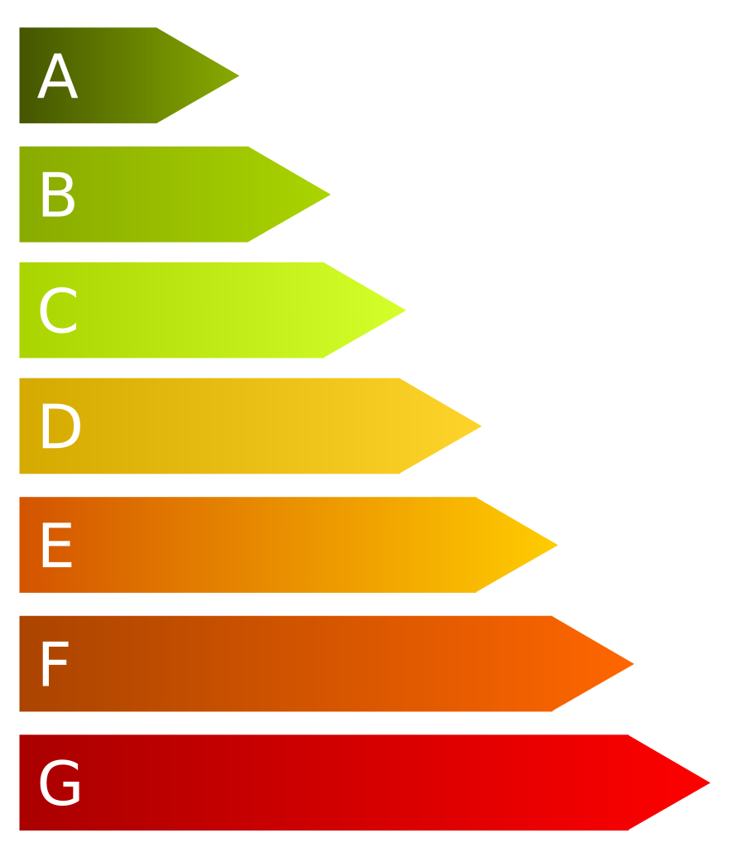**Innovation and cost efficiency in production techniques is closely linked to more efficient machines. New machines make better use of inserted raw materials, allow the reuse and reflux of process energy and consume less energy over all. This also includes cooling devices and applies to office products.**

<October>

<Year>

<Company logo>

**Energy efficient machinery in production and households**

**The European Union energy label, which was first introduced in1992, supports European consumers in purchasing energy efficient electrics (EU Directive 92/75/EC). Most white goods such as washing machines, refrigerators, dishwashers, hoovers, TVs, heating systems, light bulb packaging, cars and many others must have an EU Energy Label or similar information clearly displayed when offered for sale or rent. The energy efficiency of the appliance is rated in terms of a set of energy efficiency classes from A to G on the label, A being the most energy efficient, G the least efficient.**

**From the information about energy consumption, it is possible to easily calculate the money that can be saved over the devices’ life time.**

***TIP:******The labels do not only indicate energy efficiency but also information related to quality and function.***

Kontakt: Marina Musterfrau, musterfrau@beispielfirma.de

Co-funded by the Erasmus+ Programme of the European Union

*„The European Commission support for the production of this publication does not constitute an endorsement of the contents which reflects the views only of the authors and the Commission cannot be held responsible for any use which may be made of the information contained therein.”*

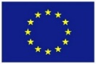

Contact: <Name>, <mailcontact@companyname.eu>

Kontakt: Marina Musterfrau, musterfrau@beispielfirma.de